CS 255 Business Requirements Document Template

System Components and Design

Purpose
What is the purpose of this project? Who is the client and what do they want their system to be able to do?
- The purpose of this project is to develop a web-based driver training management system for DriverPass that addresses the market need for comprehensive DMV test preparation
- Client (Liam, DriverPass owner) requires a system to manage online classes, practice tests, on-the-road training scheduling, and customer registration
- System will serve multiple user types: customers (students), administrative staff (secretary), IT personnel, and business owner
- Primary goal is to reduce the 65% DMV driving test failure rate by providing integrated training resources and progress tracking

System Background
What does DriverPass want the system to do? What is the problem they want to fix? What are the different components needed for this system?
- DriverPass identified a significant market gap: existing driver training resources are fragmented and insufficient for DMV test preparation
- Current business model involves phone-based customer registration, manual appointment scheduling, in-person classroom instruction, and driving lessons with instructors
- System must integrate three training packages: Package One (6 hours driving), Package Two (8 hours driving + classroom), and Package Three (12 hours driving + classroom + online practice)
- Business operates with 10 vehicles and multiple drivers that must be coordinated with customer lesson schedules
- Each driving lesson is exactly two hours in duration and requires driver-to-customer and vehicle assignments
- System must maintain real-time synchronization with DMV to ensure practice tests and course content reflect current rules and policies
- Current manual processes create tracking challenges and limit Liam's ability to access business data remotely

Objectives and Goals
What should this system be able to do when it is completed? What measurable tasks need to be included in the system design to achieve this?
- Enable customers to view their online test progress including test name, time taken, score, and completion status (not taken, in progress, failed, passed)
- Allow customers to schedule, modify, and cancel two-hour driving lessons through both online portal and phone with secretary assistance
- Automatically track and assign available drivers and vehicles to each scheduled lesson
- Maintain comprehensive audit trail showing who created, modified, or canceled each reservation for accountability
- Provide Liam with ability to download reports and data for offline analysis in Excel without modifying online records
- Support flexible package management allowing Liam to disable packages without requiring developer code changes
- Receive automatic notifications when DMV updates rules, policies, or practice questions and incorporate changes into system
- Implement role-based access control so different users (owner, IT admin, secretary, customers) have appropriate permissions
- Create customer registration system capturing all necessary information for scheduling and payment processing
- Generate activity reports that clearly identify which user is responsible for each action in the system

Requirements

Nonfunctional Requirements
In this section, you will detail the different nonfunctional requirements for the DriverPass system. You will need to think about the different things that the system needs to function properly.

Performance Requirements
What environments (web-based, application, etc.) does this system need to run in? How fast should the system run? How often should the system be updated?
- System must operate as a cloud-based web application accessible from any internet-connected computer or mobile device
- System must support concurrent access from multiple users (customers, staff, admin) without performance degradation
- All modifications to data (scheduling, registration updates, payments) must occur in real-time online only; offline editing is not permitted to prevent data redundancy
- Liam may download read-only data exports for offline review in applications like Excel
- System must provide immediate user feedback when actions are completed (successful registration, appointment booking confirmation, status updates)
- DMV updates must be received and processed automatically with administrator notification
- System must be available during standard business hours with minimal downtime

Platform Constraints
What platforms (Windows, Unix, etc.) should the system run on? Does the back end require any tools, such as a database, to support this application?
- System must be web-based, preferably cloud-hosted to eliminate need for on-premise server management
- Cloud infrastructure provider must handle automatic backups and security maintenance
- Must be accessible through standard web browsers on desktop computers, tablets, and smartphones
- Backend relational database required to store customer information, reservations, lesson records, test progress, and driver notes
- No platform-specific applications required (no Windows-only or macOS-only builds)
- System must support payment processing integration for credit card transactions
- Cloud provider responsible for data security, encryption, and compliance standards

Accuracy and Precision
How will you distinguish between different users? Is the input case-sensitive? When should the system inform the admin of a problem?
- User authentication through username and password login
- Automatic password reset capability for customers who forget credentials
- System must distinguish between four user roles: customer, secretary, IT administrator, and owner (each with different permissions)
- Input validation required for all customer information fields (phone number format, email format, address fields)
- Every modification to reservations, customer records, or lesson information must be logged with timestamp
- Audit logs must capture: who made the change, what was changed, and when the change occurred
- Activity reports must clearly identify the responsible user for each reservation creation, modification, or cancellation
- System must generate printable activity reports for Liam's record-keeping and investigation purposes
- Status tracking for lessons must be accurate to prevent double-booking of drivers or vehicles

Adaptability
Can you make changes to the user (add/remove/modify) without changing code? How will the system adapt to platform updates? What type of access does the IT admin need?
- IT administrator (Ian) must have full account management access without requiring code changes: password resets, account lockouts, user blocking
- Liam must be able to disable training packages (prevent new enrollments) without developer involvement; disabling should not affect existing customer data
- System architecture must support future addition of new training packages by developers without major restructuring
- System must accommodate DMV rule and policy updates without requiring database schema changes
- Role-based access control should be configurable to support potential addition of new user types in future releases
- Interface should be flexible to accommodate future feature additions identified by client

Security
What is required for the user to log in? How can you secure the connection or the data exchange between the client and the server? What should happen to the account if there is a “brute force” hacking attempt? What happens if the user forgets their password?
- User login required with username and password authentication
- Password recovery: customers can automatically reset forgotten passwords without IT administrator assistance
- Role-based access control implemented for all four user types:
  - IT Administrator (Ian): Full system access, account management, password resets, user account blocking/unblocking
  - Secretary: Customer registration data entry, appointment scheduling on behalf of customers, view customer information
  - Customers: Self-service online appointment scheduling, appointment modification/cancellation, view personal progress and driver notes
  - Owner (Liam): System access, reporting, package management, activity log review
    - Encrypted connection (HTTPS/SSL) required for all data transmission between client browser and server
    - Credit card information (number, expiration date, security code) must comply with PCI-DSS standards and never stored on local systems
    - Account lockout policy required after multiple failed login attempts to prevent brute-force attacks
    - Automatic session timeout for inactive users to prevent unauthorized access on shared devices
    - All user actions logged with timestamp and user identification for audit trail

Functional Requirements
Using the information from the scenario, think about the different functions the system needs to provide. Each of your bullets should start with “The system shall . . .” For example, one functional requirement might be, “The system shall validate user credentials when logging in.”
- The system shall validate user credentials and authenticate users upon login with username and password
- The system shall deny access and display error message for invalid login credentials
- The system shall support customer registration initiated by phone call with secretary data entry
- The system shall capture and store customer information during registration: first name, last name, address, phone number, state, credit card number, expiration date, security code, pickup location, and drop-off location
- The system shall default drop-off location to match pickup location
- The system shall enable customers to register and create accounts online for future self-service scheduling
- The system shall present three training package options (Package One, Two, Three) and require customer to select one during registration
- The system shall allow owner to disable training packages to prevent new customer enrollment without affecting existing students
- The system shall enable customers to schedule two-hour driving lessons by selecting preferred date and time through online portal
- The system shall allow customers to modify scheduled lessons (change date/time) through online portal
- The system shall allow customers to cancel scheduled lessons with appropriate notifications
- The system shall enable secretary to schedule, modify, and cancel appointments on behalf of customers via phone
- The system shall automatically assign available drivers and vehicles to each scheduled lesson based on current availability
- The system shall display and track lesson details: lesson date, start time, end time, assigned driver name, vehicle assigned, and driver comments
- The system shall maintain driver notes field where instructors can document lesson observations and student performance
- The system shall create and maintain complete activity log for all reservations showing: who created it, when it was created, who last modified it, when modification occurred, who canceled it, and when cancellation occurred
- The system shall generate activity reports that allow Liam to identify responsible party for each reservation action
- The system shall track online test progress for each customer showing: test name, time taken to complete, score received, and current status
- The system shall support four test status values: not taken, in progress, failed, passed
- The system shall receive automatic updates from DMV for new rules, policies, and sample questions
- The system shall notify administrator when DMV updates are available for review
- The system shall allow Liam to download reports and customer data for offline analysis and modification in Excel
- The system shall allow Liam to re-upload modified offline data back into system when online
- The system shall process credit card payments securely at time of registration
- The system shall support automatic password reset for customers without IT administrator involvement
- The system shall prevent data modification during offline/disconnected mode to prevent data duplication and conflicts

User Interface
What are the needs of the interface? Who are the different users for this interface? What will each user need to be able to do through the interface? How will the user interact with the interface (mobile, browser, etc.)?
- System must be accessible through web browsers on desktop computers and mobile devices (responsive design)
- Main customer dashboard shall display: online test progress, lesson history with driver notes, customer profile information
- Customer registration form shall include fields: first name, last name, address, city, state, zip code, phone number, email
- Online test progress section shall display table with columns: test name, time taken, score, status
- Driver notes section shall display table with columns: lesson time, start hour, end hour, driver comments
- Special needs section to capture any student accommodations or requirements
- Driver photo and student photo sections for identification purposes
- Appointment management interface allowing customers to view, schedule, modify, and cancel lessons
- Contact page with inquiry form and company contact information
- Administrator portal for staff to enter customer registrations and manage packages
- Owner dashboard for viewing reports and system analytics
- Consistent DriverPass branding and logo placement throughout interface
- Intuitive navigation menu for accessing different sections
- Clear visual indicators for appointment status and test progress

Assumptions
What things were not specifically addressed in your design above? What assumptions are you making in your design about the users or the technology they have?
- Students have reliable internet access at home or on mobile devices for online scheduling and test completion
- Customers possess valid credit cards for payment processing at time of registration
- DMV will provide API connection or notification system for automatic rule and policy updates
- All system users (secretary, IT admin, owner, customers) have basic computer literacy and web browser familiarity
- Cloud infrastructure will have sufficient capacity to handle expected user load during peak business hours
- All driving lessons occur during standard business hours (8 AM - 6 PM)
- Pickup and drop-off locations are the same; no multi-location routing required
- Each vehicle is permanently assigned to one driver
- Each driving lesson is exactly two hours in duration
- Customer payment method (credit card) is valid at time of registration
- Background checks and driver licensing verification are handled through separate processes outside this system
- Customers will have access to private vehicle for practice between lessons or will not require this feature

Limitations
Any system you build will naturally have limitations. What limitations do you see in your system design? What limitations do you have as far as resources, time, budget, or technology?
- Developer Dependency for Customization: Adding or removing training packages requires developer code changes; flexible package creation without developer involvement is deferred to future releases
- Single Region Focus: System designed for single DMV jurisdiction; expansion to multiple states with different DMV rules would require significant enhancement
- Limited Project Timeline: 19-week timeline (Jan 22 - May 10) constrains scope; comprehensive testing window is only 10 business days
- Cloud Provider Dependency: System availability and security dependent on cloud provider uptime and policies; no on-premise backup alternative specified
- Payment Processing: Reliance on third-party payment processor adds costs and introduces external dependency for system reliability
- Scalability Constraints: Design untested at scale; expansion beyond small regional operation may require database optimization and infrastructure scaling
- DMV Integration Dependency: System effectiveness dependent on DMV providing timely rule updates; manual content updates required if automatic API unavailable
- Geographic Limitations: Vehicle routing and lesson scheduling do not account for traffic patterns or geographic distance constraints
- Support Hours: System support and IT administration limited to business hours; customers cannot resolve issues outside standard operating times
- No Offline Mobile App: Customers must use web browser; native mobile app deferred to future phases

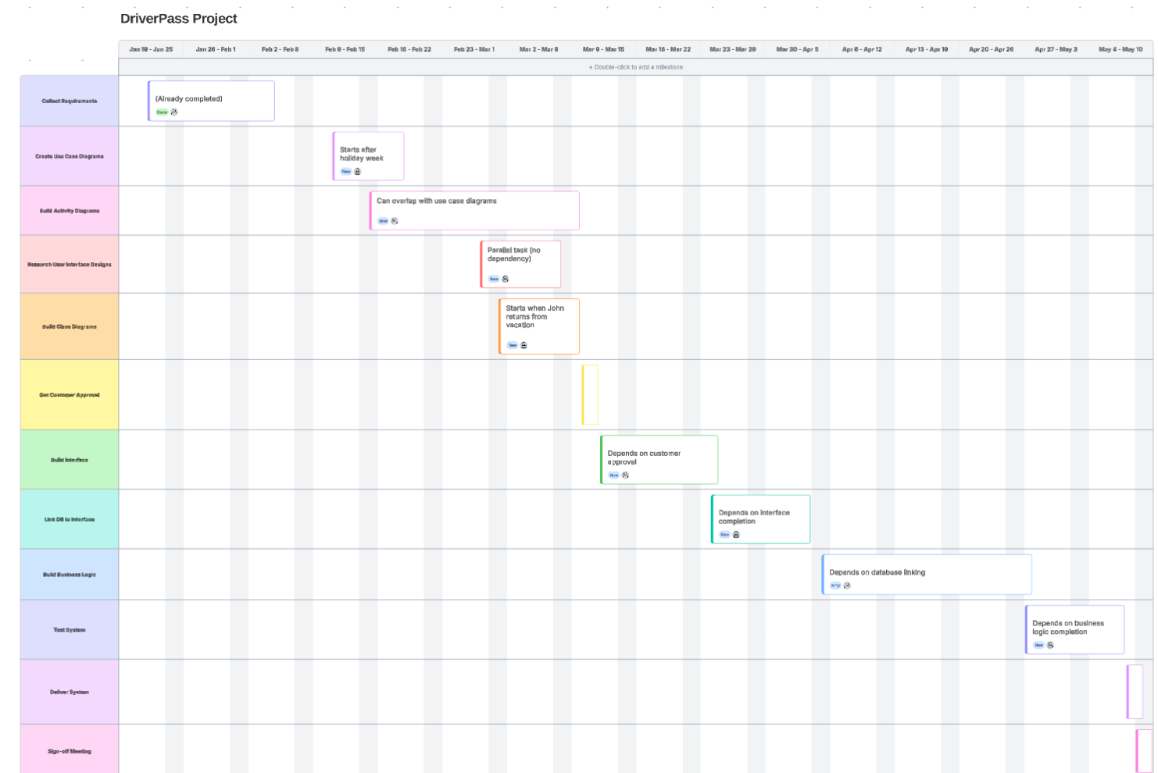
Gantt Chart

